Book & Noble – Web Content

Home Page
Meta Title: Professional Book Publishing Services | Book & Noble
Meta Description: Publish your book with expert Amazon KDP support. Full-service book publishing, writing, formatting, and global distribution for authors.


Best Company to Publish Your First Book
Get Published Within 48 Hours
100% Royalties • Bestseller-Ready • Globally Distributed
Book & Noble delivers professional book publishing services designed for authors. As a trusted book publishing company in the USA, we specialize in self publishing. We help you get your book professionally published across Amazon, Barnes & Noble, and worldwide platforms.
(Add Buttons at the end of this section)
- Get Free Quote
- Our Services
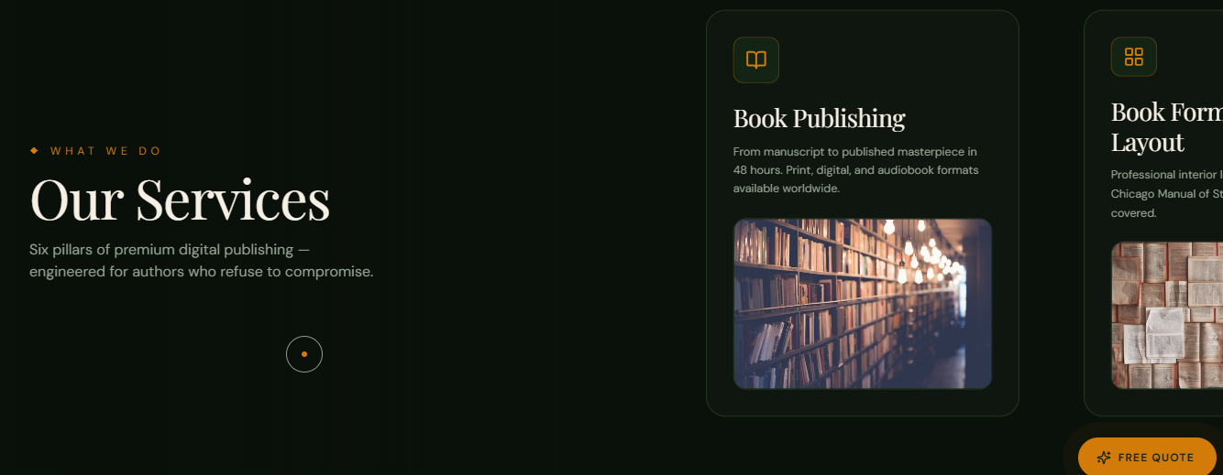
What We Do
Complete Book Publishing Services
We offer full service book publishing packages designed to support authors at every stage. Whether you need professional book writing services, Amazon KDP publishing, or book formatting and publishing, our team delivers everything.
Book Publishing
Get your book published in just 48 hours with our book publishing services. We handle everything from production to Amazon book publishing services and multi-platform distribution.
Ghostwriting
Need help writing your book? Hire a book writer online and work with experienced fiction book writing consultants and non-fiction book writing experts who bring your ideas to life.
Book Editing & Proofreading
Our editors polish your manuscript through detailed editing and proofreading. We make sure your book meets professional publishing standards while maintaining your unique voice.
Book Formatting
We provide professional KDP book formatting services to ensure your book is perfectly structured for Kindle, print, and digital platforms with industry-standard layouts.
Amazon Optimization
Maximize your visibility with expert Amazon KDP publishing support. Hire an expert for Amazon KDP setup, keyword optimization, category placement, and listing enhancements to boost rankings and sales.
Book Cover Design
Stand out in a competitive market with visually compelling, genre-specific cover designs that capture attention and increase conversions across online bookstores.
Social Media Marketing
Grow your audience with targeted marketing strategies designed for authors. We help you build visibility, engagement, and long-term brand presence across social platforms.
Global Book Distribution
Reach readers worldwide through our Amazon book publishing services and global distribution network. This way, we make your book available across major online retailers and marketplaces.


Join Thousands of Authors Using Our Professional Book Publishing Services

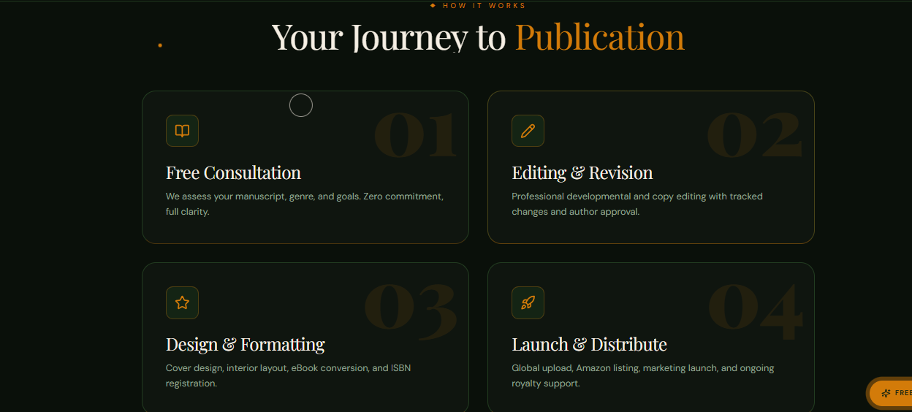
How It Works
Your Journey to Amazon KDP Success
01. Free Consultation
Start with a personalized consultation where we evaluate your manuscript, genre, and publishing goals. We provide clear guidance on the best path forward, including full service book publishing packages according to your needs.
02. Editing & Professional Revision
Our editors enhance your manuscript through detailed editing and proofreading. This stage ensures your book meets industry standards.
03. Cover Design & Book Formatting
We handle every aspect of design, from eye-catching covers to professional KDP book formatting services. Your book is structured for seamless readability and optimized for Kindle, paperback, and global distribution.
04. Launch & Distribution
We finalize your Amazon book publishing services, including expert Amazon KDP setup, keyword optimization, and category placement.

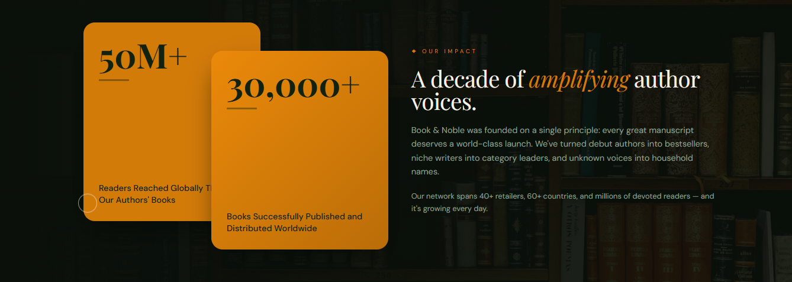
A Leading Book Publishing Company Delivering Global Author Success
Book & Noble goes beyond basic publishing. We build author success stories. We have helped thousands of writers navigate self publishing and turn their manuscripts into professionally published books with global reach.
From first-time authors searching for the best company to publish my first book to experienced writers expanding their audience through Amazon book publishing services, our approach is centered on quality, visibility, and long-term growth.
50M+
Readers Reached Through Published Books
30,000+
Books Successfully Published & Distributed


Meet Our Expert Team Behind the Magic
Behind every successful book is a team that understands the publishing journey inside out. Our specialists include experienced editors, creative designers, Amazon KDP publishing experts, and marketing strategists who work together to deliver high-quality book publishing services to each author.


Testimonials
See What Our Clients Have to Say About Us
Emily Carter
Working with Book & Noble made the entire publishing process feel effortless. As a first-time author, I had no idea where to start but their team guided me through everything. Seeing my book live on Amazon was surreal.
Daniel Brooks
I was specifically looking for reliable Amazon KDP publishing support, and they delivered beyond expectations. The optimization alone helped my book gain visibility within weeks.
Sophia Reynolds
Their book editing and proofreading team is exceptional. They refined my manuscript without changing my voice, which meant a lot to me as a writer.
Michael Turner
I hired them for professional book writing services, and the experience was smooth from start to finish. The writer understood my vision perfectly and delivered something I’m truly proud of.
Olivia Bennett
The cover design and book formatting services were top-tier. My book looks just as professional as anything you’d find in a bookstore.
Nathan Collins
I needed a team that could handle everything from writing to publishing. Their full service book publishing package saved me months of effort and confusion.
Hannah Scott
I was searching for the best company to publish my first book and I’m glad I chose them. They made the process simple, transparent, and actually enjoyable.

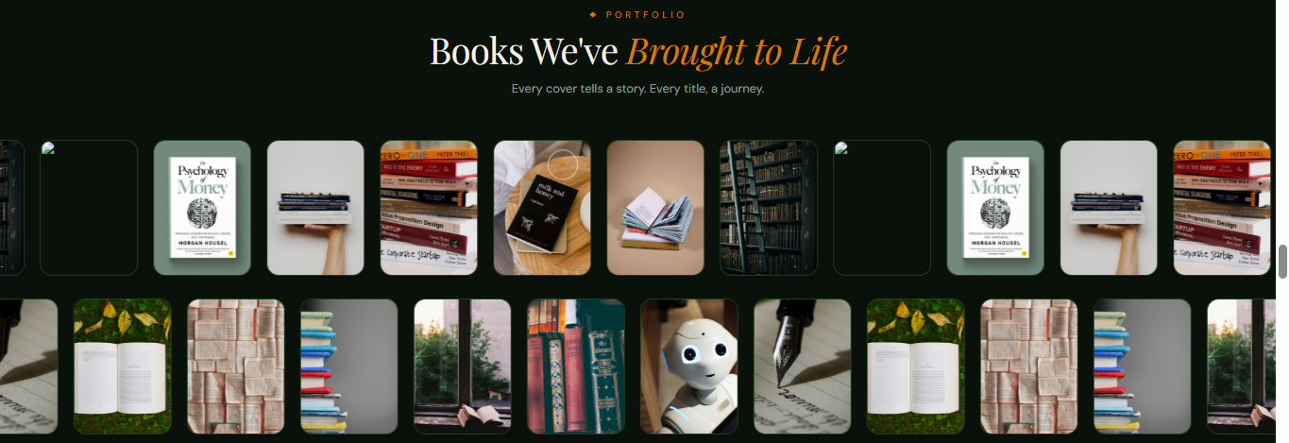
Our Portfolio
Books Brought to Life By Us
See our diverse collection of titles created through our professional book publishing services, where every book reflects a unique vision brought to life with creativity.

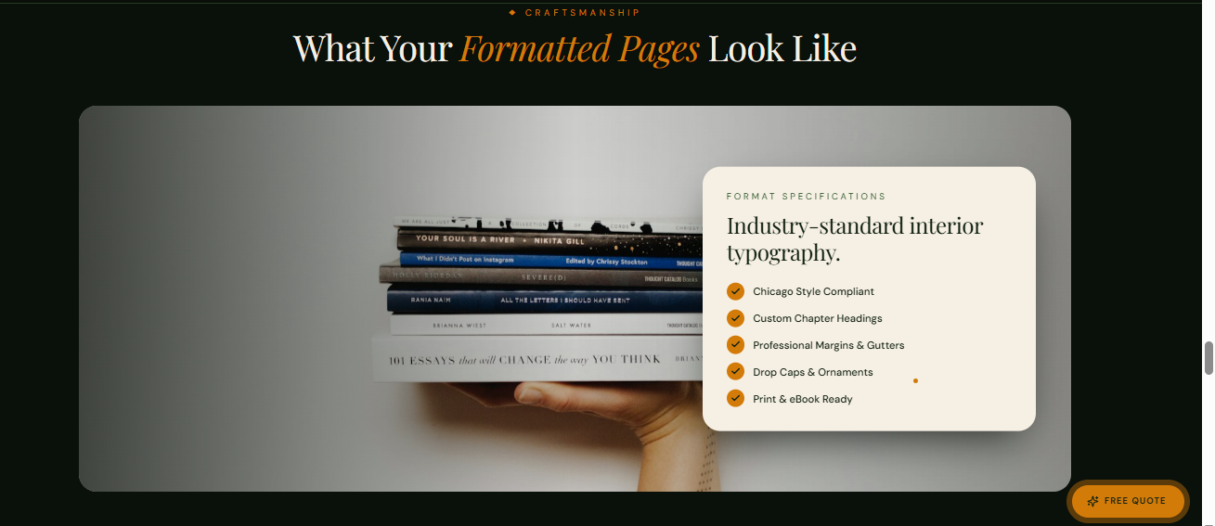
What Your Formatted Pages Look Like
Industry-Standard Interior Formatting for Every Genre
We focus on delivering high-quality book formatting and publishing solutions that include:
- Chicago Style–Compliant Formatting
- Custom Chapter Headings
- Balanced Margins and Gutters
- Elegant Drop Caps and Stylistic Elements
- Print and eBook Ready Files


Expert Insights on Book Publishing & Amazon KDP
Stay ahead in your publishing journey with insights from industry professionals. Our blog offers practical advice on self publishing, Amazon KDP publishing, and building a successful author brand.

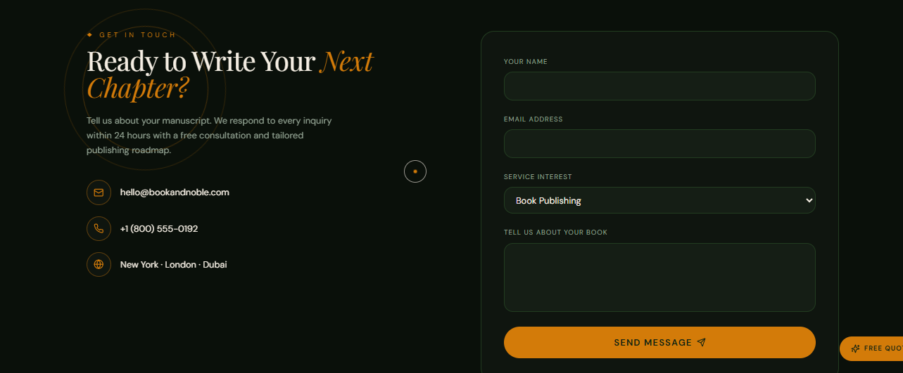
Get in Touch
Ready to Write Your Next Chapter with a Professional Publishing Company?
Take the next step toward becoming a published author with a trusted book publishing company in the USA. Tell us about your book, and we’ll create a plan based on your goals, genre, and publishing vision.

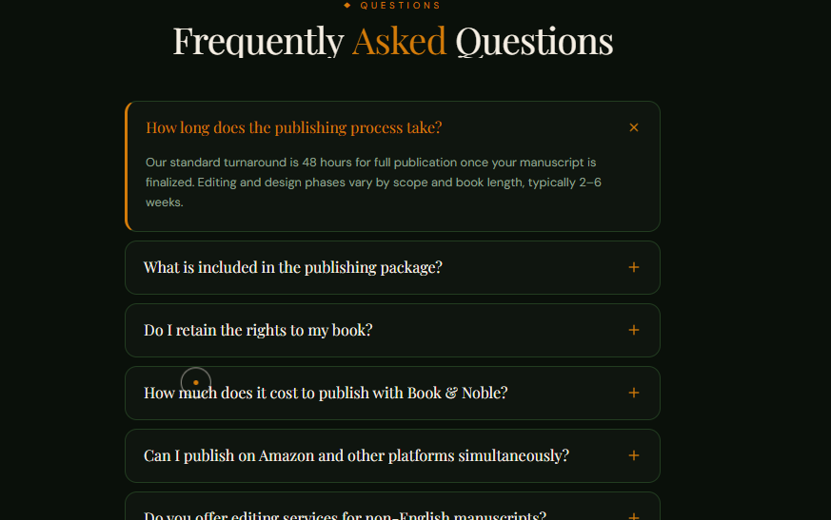
Frequently Asked Questions
1. What are professional book publishing services?
Professional book publishing services include everything needed to turn your manuscript into a published book, such as editing, formatting, cover design, and distribution. A full-service provider helps authors navigate self publishing and launch their books across major platforms.
2. How do I publish my first book?
To publish your first book, you need to prepare your manuscript, format it properly, design a cover, and upload it to platforms like Amazon. Many authors choose a book publishing company in the USA to handle the process professionally and avoid technical challenges.
3. What is Amazon KDP publishing?
Amazon KDP publishing (Kindle Direct Publishing) is a platform that allows authors to self-publish eBooks and paperbacks. With expert guidance, you can optimize your book listing, improve visibility, and reach a global audience.
4. Do you offer full service book publishing packages?
Yes, we offer full service book publishing packages that cover writing, editing, book formatting and publishing, cover design, and Amazon book publishing services, ensuring a complete end-to-end solution.
5. Can I hire a professional to write my book?
Absolutely. You can hire a book writer online through our professional book writing services. Our team includes experienced fiction book writing consultants and non-fiction book writing experts who can bring your ideas to life.
6. What is included in book formatting and publishing?
Book formatting and publishing includes structuring your manuscript for readability, applying professional layouts, and preparing files for Kindle, print, and other digital platforms.
7. How long does it take to publish a book?
The timeline varies depending on the services required. Basic Amazon KDP publishing can take a few days, while complete book publishing services including editing and design may take a few weeks.
8. Do I retain rights to my book?
Yes, with our self publishing model, authors retain full ownership and rights to their work, including royalties and distribution control.
9. What makes your company the best choice for first-time authors?
We provide personalized guidance, transparent processes, and complete support, making us a trusted choice for authors searching for the best company to publish my first book.
10. Do you help with Amazon optimization?
Yes, we offer expert Amazon book publishing services, including keyword optimization, category selection, and listing enhancement to improve your book’s visibility and ranking.
11. Can you publish my book globally?
Yes, we provide global distribution through Amazon KDP publishing and other platforms, making your book available to readers worldwide.
12. How do I get started with your publishing services?
You can get started by filling out our contact form or requesting a free consultation. Our team will review your manuscript and recommend the best book publishing services based on your goals.

